Sprint 1 Materials

Digital Dawg Pack



Ethan Woods

Quinn Bromley

Chance Hughes

Jacob Kuruvilla

Kaghan Odom

Hayden O’ Keefe

# Retrospective Summary

During our Sprint 1 Retrospective Meeting, there was great discussion and insight gained as to how we should move forward and work as a group. To start, we analyzed the strengths and weaknesses of our group during Sprint 1. A major strong suit was that everyone was able to individually work efficiently. However, during this work, most members ran into one common problem: Communication. There came many times where one group member was working on a page for the website, while completely unsure of what everyone else was doing. Sure, we had tasks assigned, but the lack of communication made it difficult to truly commit to a task considering there could be another team member doing it. Because of this, we need to change our procedure regarding general check-ins and being transparent about what work is done. This could be managed through more often SCRUM meetings, especially since now we are past the initial setup humps. Finally, we discussed the design of our product backlogs, which is ultimately fine. Many members believe that a bunch of the tasks are too general, as they would not know what to do to accomplish it. To fix this, we were going to break these general tasks down into more specific, smaller tasks. We accomplished and went further than our goal of Sprint 1, which was to have our MVP deployed and viewable. We were not only able to get our MVP deployed, but we also had a head start into the customer, menu board, and cashier pages. We will be completing these going forward into Sprint 2.

# GitHub Release Link

[Github Release v1.0](https://github.com/csce-315-331-2024a/project-3-full-stack-agile-web-900-3/releases/tag/v1.0-beta)

# Product Backlog

**Time Estimates Range from (1-5), where 1 is “not very long” and 5 is “intensive work needed”**

**Priorities range from (LOW, MED, HIGH)**

**Setting up Development Environment**

**This set of tasks are dependent on each developer having angular setup along with general knowledge of how to start the Web Server on their own**

* 1. Installing Angularjs and Spring Boot (2) **HIGH**
  + Status: Completed
* 2. Sketch initial UI (1) **MED**
  + Status: Completed
* 3. Create a basic UI not including all aspects (3) **HIGH**
  + Status: Completed
* 4. Incorporate 1 functionality of our existing java backend to the front end (1) **LOW**
  + Status: Completed
* 5. Deploy web app to server (2) **HIGH**
  + Status: Completed
* 6. All members on team can run the web app (4) **HIGH**
  + Status: Completed

**Create Hosted SQL Server on AWS**

**This set of tasks is dependent on if the postgres login works. Once in, updating the database does not depend on anything else**

* 7. Migrate database content into new database (3) **HIGH**
  + Status: Completed
* 8. Update database schema (2) **HIGH**
  + Status: Completed
* 9. Deploy database to web server and ensure database is working properly (3) **HIGH**
  + Status: Completed

**Development of Menu Board Page**

**All Tasks Dependent on creation of Database and deployment of Web Server**

* 10. Create eye catching design for listing all menu items (4) **HIGH**
  + Status: In Progress
* 11. Display menu in an easy to read and engaging way (2) **MED**
  + Status: Not Started
* 12. Implement dynamic designs that show changing pictures (4) **HIGH**
  + Status: Not Started
* 13. Integrate with database (2) **HIGH**
  + Status: Not Started
* 14. Make customizable in response to additions to menu (4) **HIGH**
  + Status: Not Started
* 15. Integrate keyboard navigation through the page (3) **MED**
  + Status: Not Started

**Development of Customer Page**

**All Tasks Dependent on creation of Database and deployment of Web Server**

* 16. Create an ordering interface that is simple to navigate for the general public (4) **HIGH**
  + Status: In Progress
* 17. Make the design visually appealing for a casual user (1**) LOW**
  + Status: Not Started
* 18. Make use of images for menu items (2) **MED**
  + Status: Not Started
* 19.Implement customization for each item in the order (3) **MED**
  + Status: Not Started
* 20. Integrate with database (2) **HIGH**
  + Status: Not Started
* 21. Include simple and obvious instructions for use (1) **LOW**
  + Status: Not Started
* 22. Integrate accessibility features (5) **HIGH**
  + Status: Not Started
* 23. Include dynamic updating of the page (3) **HIGH**
  + Status: Not Started

**Development of Cashier Page**

**All Tasks Dependent on creation of Database and deployment of Web Server**

* 24. Layout buttons in a fast and efficient manner to respond to customers order (3) **HIGH**
  + Status: In Progress
* 25. Minimize number of different pages involved (1) **LOW**
  + Status: Not Started
* 26. Implement updating order list to track current order and total pricing (1) **LOW**
  + Status: Not Started
* 27. Use dynamic buttons for each item to add and remove ingredients to suit the customers specifications (3) **HIGH**
  + Status: Not Started
* 28. Implement logic to create buttons for special items that are dynamically added (3) **LOW**
  + Status: Not Started
* 29. Integrate with the database (2) **HIGH**
  + Status: Not Started
* 30. Implement taking items off the current order (1) **MED**
  + Status: Not Started
* 31. Implement a cancel order system (1) **LOW**
  + Status: Not Started

**Development of Manager Page**

**All Tasks Dependent on creation of Database and deployment of Web Server**

* 32. Layout buttons in a fast and efficient manner to respond to customers order (1) **HIGH**
  + Status: In Progress
* 33. Minimize number of different pages involved (1) **LOW**
  + Status: Not Started
* 34. Implement updating order list to track current order and total pricing (1) **MED**
  + Status: Not Started
* 35. Use dynamic buttons for each item to add and remove ingredients to suit the customers specifications (1) **HIGH**
  + Status: Not Started
* 36. Allow managers to add new menu items and specify their limited time frame if seasonal (2) **MED**
  + Status: Not Started
* 37. Implement logic to update page with new buttons for special items that are dynamically added (2) **HIGH**
  + Status: Not Started
* 38. Implement trend charts based on time interval (2) **MED**
  + Status: Not Started
* 39. Integrate with the database (2) **HIGH**
  + Status: Not Started

**API Integration into Web Page**

**All tasks are dependent on each of their respective pages being completed. Tasks can be done in any order, but if the page is not completed, then API integration could cause issues**

* 40. Learn architecture of Google Authentication API (api keys, libraries/dependencies in spring-boot) (4) **HIGH**

1. Decide whether we need to request from the backend to do more business logic or request straight from the front end
2. Create either front end logic or front end + back end logic.

* 41. Learn structure of openweather API (api keys, libraries/dependencies in spring-boot) (4) **HIGH**
  + Repeat steps 1, 2 from above
* 42. Learn structure of google translate API(api keys, libraries/dependencies in spring-boot) (4) **HIGH**
  + Repeat steps 1, 2 from above
* 43. Implement Authentication Login Page (2) **HIGH**
  + Status: Not Started
* 44. Integrate Authentication into Manager Page (similar to task 44) (1) **MED**
  + Status: Not Started
* 45. Implement weather module into menu page (2) **MED**
  + Status: Not Started
* 46. Integrate dynamic naming of items based on current weather (3) **HIGH**
  + Status: Not Started
* 47. Implement translation API into Menu Page (3) **HIGH**
  + Status: Not Started
* 48. Implement translation API into Customer Page (2) **HIGH**
  + Status: Not Started

**Web Accessibility Tasks**

**All tasks are dependent on each of their respective pages being completed. Once each page is done, adding accessibility is along the lines of updating format, color, size, etc.**

* 49. Ensure all non-text content on the web app has a text alternative (2) **HIGH**
  + Status: Not Started
* 50. Ensure that the content is adaptable (presented in different ways without losing information) (3) **HIGH**
  + Status: Not Started
* 51. Ensuring that content is easier for users to see and hear. Separating content from background. (3) **MED**
  + Status: Not Started
* 52. Ensuring implementation features for Carol (3) **HIGH**
  + Status: Not Started
* 53. Ensuring implementation features for Maria. (3) **HIGH**
  + Status: Not Started
* 54. Ensuring implementation features for Lea. (3) **HIGH**
  + Status: Not Started
* 55. Ensuring keyboard accessibility. (3) **HIGH**
  + Status: Not Started
* 56. Ensuring users enough time to read and use content (1) **LOW**
  + Status: Not Started
* 57. Ensuring minimization of seizure and physical reaction provoking responses (1) **LOW**
  + Status: Not Started
* 58. Ensuring Navigation accessibility (3) **HIGH**
  + Status: Not Started
* 59. Ensuring multiple input modalities (3) **LOW**
  + Status: Not Started
* 60. Ensuring readability and clear/understandable text. (2) **MED**
  + Status: Not Started
* 61. Ensuring predictability (2) **LOW**
  + Status: Not Started
* 62. Input assistance (help users avoid and correct mistakes) (2) **LOW**
  + Status: Not Started

Sprint Backlog

**Setting up Development Environment**

Installing Angularjs and Spring Boot (2) HIGH

Time Estimate: 2.

Assigned to: Hayden O’ Keefe

Actual Time Spent: 2.

Status: Completed

Sketch initial UI (1) MED

Time Estimate: 1.

Assigned to: Kaghan Odom

Actual Time Spent: 1.

Status: Completed

Create a basic UI not including all aspects (3) HIGH

Time Estimate: 3.

Assigned to: Quinn Bromley

Actual Time Spent: 3.

Status: Completed

Incorporate 1 functionality of our existing java backend to the front end (1) LOW

Time Estimate: 1.

Assigned to: Hayden O’Keefe

Actual Time Spent: 1.

Status: Completed

Deploy web app to server (2) HIGH

Time Estimate: 2.

Assigned to: Hayden O’ Keefe

Actual Time Spent: 2.

Status: Completed

All members on team can run the web app (4) HIGH

Time Estimate: 4.

Assigned to: All members

Actual Time Spent: 4.

Status: Completed

**Create Hosted SQL Server on AW**

Migrate database content into new database (3) HIGH

Time Estimate: 3.

Assigned to: Jacob Kuruvilla

Actual Time Spent: 3.

Status: Completed

Update database schema (2) HIGH

Time Estimate: 2.

Assigned to: Chance Hughes

Actual Time Spent: 2.

Status: Completed

Deploy database to web server and ensure database is working properly (3) HIGH

Time Estimate: 3.

Assigned to: Ethan Woods

Actual Time Spent: 3.

Status: Completed

**Development of Menu Board Page**

Create an eye catching design for listing all menu items (4) HIGH

Time Estimate: 4.

Assigned to: Hayden’ O'Keefe

Actual Time Spent: 1.

Status: In Progress

**Development of Customer Page**

Create an ordering interface that is simple to navigate for the general public (4) HIGH

Time Estimate: 4.

Assigned to: Jacob K., Chance H., and Ethan W.

Actual Time Spent: 1. Status: In progress

**Development of Cashier Page**

Layout buttons in a fast and efficient manner to respond to customers order (3) HIGH

Time Estimate: 3.

Assigned to: Kaghan Odom and Quinn Bromley

Actual Time Spent: 2.

Status: In progress

**Development of Manager Page**

Layout buttons in a fast and efficient manner to respond to customers order (1) HIGH

Time Estimate: 1.

Assigned to: Kaghan Odom

Actual Time Spent: 0.

Status: In progress

| **Name** | **# Tasks Completed for Sprint 1** | **# Tasks Completed for Sprint 2** | **# Tasks Completed for Sprint 3** |
| --- | --- | --- | --- |
| Ethan Woods | 2 tasks (8 time estimate) |  |  |
| Hayden O’Keefe | 4 tasks (10 time estimate) |  |  |
| Kaghan Odom | 2 tasks (7 time estimate) |  |  |
| Chance Hughes | 2 tasks (8 time estimate) |  |  |
| Quinn Bromley | 2 tasks (8 time estimate) |  |  |
| Jacob Kuruvilla | 2 tasks (7 time estimate) |  |  |

# 

# Burn-down Charts

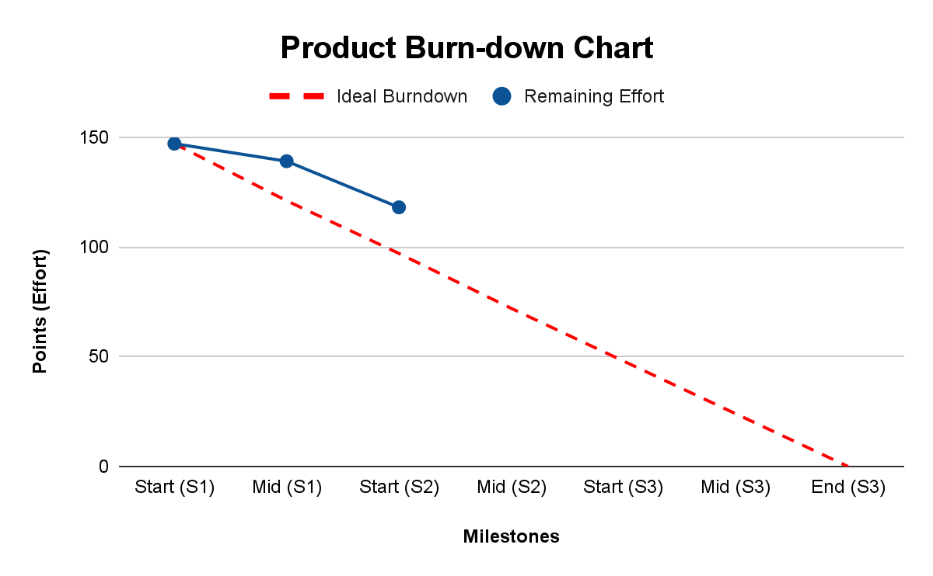

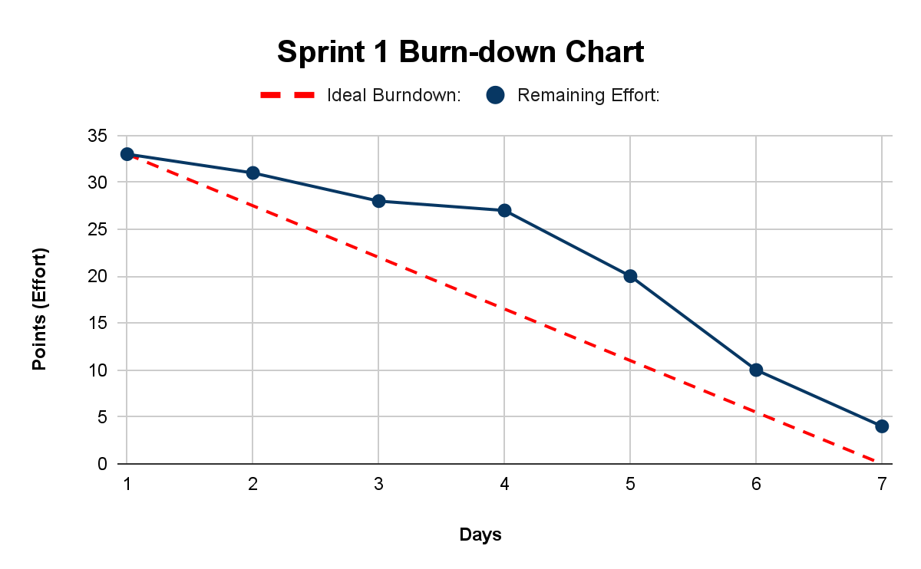

# Next Sprint’s SCRUM Meeting Schedule

Work Schedule

**Friday 4/5/24**

**Scrum Meeting #1**

Time TBD;

**Monday 4/8/24**

**Scrum Meeting #2**

8:00-8:50 AM; Lab

8:55-9:10 AM; Stand-up Meeting

**Tuesday 4/9/24**

8:00-9:15 AM; Class

7:45-10:00 PM; Group Work Session (Possible time change)

**Wednesday 4/10/24**

**Scrum Meeting #3**

8:00-8:50 AM; Lab

8:55-9:10 AM; Stand-up Meeting

**Thursday 4/11/24**

8:00-9:15 AM; Class

7:30-10:00 PM; Group/Partner Work Session (Possible Time change)

**Sunday 4/14/24**

**Last Meeting Before Sprint 2 MVP**

Work Session (Time TBD)

* Powerpoint creation and design for product showcase

Appendix 1: SCRUM Meeting Agendas and Minutes

SCRUM Meeting 1 for Project 3 Sprint 1

Prepared by: Chance Hughes

Meeting Date: 03/25/2024

## Meeting Attendees

1. Ethan Woods
2. Hayden O’Keefe
3. Quinn Bromley
4. Kaghan Odom
5. Chance Hughes
6. Jacob Kuruvilla

## Meeting Agenda Items

* What should our first goal be?
* How should we start this project the first week?
* Which framework are we going to use for this project?

## Status Update Since Last Meeting

No previous meeting before. This was the first Scrum meeting.

Task Assignments:

| **Task Description** | **Assigned to** |
| --- | --- |
| Do framework research and begin planning which framework to use | Hayden, Kaghan, Quinn |
| Update and talk about new database schema to better fit needs | Chance, Jacob, Ethan |

## Minutes from Previous Meeting

No previous meeting. This was our first Scrum meeting. We met before to design the Design Document, but there weren't really many roles or tasks handed out then.

SCRUM Meeting 2 for Project 3 Sprint 1

Prepared by: Ethan Woods

Meeting Date: 3/27/24

## Meeting Attendees

1. Ethan Woods
2. Hayden O’Keefe
3. Quinn Bromley
4. Kaghan Odom
5. Chance Hughes
6. Jacob Kuruvilla

## Meeting Agenda Items

* Have we discovered what framework to use?
* Has the database been updated?
* Will we be able to deploy the website before the MVP release date?

## Status Update Since Last Meeting

Accomplishments:

* Insight into which framework to use was gained (Spring Boot and HXML)
* Web server was not deployed yet, but effort was gained
* Database logins were successful, but updating has not finished yet

Tasks Completed:

| **Task Description** | **Assigned to** | **Completed? (yes/no)** |
| --- | --- | --- |
| Do framework research and begin planning which framework to use | Hayden, Kaghan, Quinn | no |
| Update and talk about new database schema to better fit needs | Chance, Coby, Ethan | no |

## Before The Next Meeting

Plans:

* Keep working towards figuring out how to host the web server on Google Cloud AppEngine
* Work towards updating the schema in the database by updating py and SQL files

Task Assignments:

| **Task Description** | **Assigned to** |
| --- | --- |
| Host the web server on Google Cloud App Engine to be ready for deployment | Hayden, Kaghan, Quinn |
| Update database schema by fixing broken schema | Chance, Coby, Ethan |

## Minutes from Previous Meeting

Our first Scrum meeting was the first meeting where we began to set up tasks. There was really no real work done yet, but we were just beginning to lay the groundwork of what we needed to have done.

SCRUM Meeting 3 for Project 3 Sprint 1

Prepared by: Ethan Woods

Meeting Date: 3/31/24

## Meeting Attendees

1. Ethan Woods
2. Hayden O’Keefe
3. Quinn Bromley
4. Kaghan Odom
5. Chance Hughes
6. Jacob Kuruvilla

## Meeting Agenda Items

* Get our website hosted on Google Cloud App Engine
* Finalize updating the database schema in the postgres database
* Merge our branches of work that was done throughout the weekend before our MVP

## Status Update Since Last Meeting

Accomplishments:

* A basic version of the web server was hosted on AppEngine
* The database schema was updated for better query use and graph design when pulling trends
* Starter designs for the menu board, cashier page, and customer page were completed
* Database integration was completed

Tasks Completed:

| **Task Description** | **Assigned to** | **Completed? (yes/no)** |
| --- | --- | --- |
| Do framework research and begin planning which framework to use | Hayden, Kaghan, Quinn | yes |
| Update database schema by fixing broken schema | Chance, Coby, Ethan | yes |

## Before The Next Meeting

Plans:

* MVP needs to be deployed for demo the next day
* Merge code before MVP demo and submission
* Finalize MVP Sprint 1 design

Task Assignments:

| **Task Description** | **Assigned to** |
| --- | --- |
| Merge all branches with main with features used in MVP | All |
| Ensure web server deployment is up and deployed | All |

## Minutes from Previous Meeting

During the last meeting, we discussed our Sprint 1 goals and work that was needed to be done before MVP deployment. We agreed to work over the weekend since we had a busy end of the week going from Wednesday to Friday. We kept work divided up as it was after the first meeting, so not much changed in terms of task assignment. We just had one goal: GET THE MVP UP!